Un chemin de briques et de sang au Familistère- Service éducatif du Familistère de Guise
++++++++++++++++++++++++++++++++++++++++++++++++++++++++++++++++++++++++++++++++++++++++++++++++++++++++++++++++++++++++++++++++++++++++++++
Les Deneux défaits
6. Pourquoi les Deneux ne sont-ils pas morts à cause de leur poêle ?
………………………………………………….…………………………………………………. ………………………………………………….………………………………………………….………………………………………………….…………………………………………………. ………………………………………………….………………………………………………….………………………………………………….…………………………………………………. ………………………………………………….………………………………………………….

Leutellier meurt sur scène
10. Pourquoi les auteurs ont-ils choisi le théâtre comme lieu de suicide de l’administrateur-gérant Leutellier ? ………………………………………………….…………………………………………………. ………………………………………………….………………………………………………….………………………………………………….……………………………………………………………………….
La mort du vieil Aristide
1. A quoi sert le jardin ? ……………………………………………………………………………………………………………………………………………………
2. Qui est enterré dans ce lieu de vie ? ……………………………………………
……………………………………..………………………………………………………………………………………………………….
Une cour centrale pour les Familistériens
8. A quoi servaient les associés ? …………………………………
………………………………. ……………………………………................
……………………………………………………………………………………………………………………………………………………………………………………………………………………………………………………………………..
9. Que faisaient les enfants dans la cour tous les jours ? …………………………………………………………………………..
Une fois par an ? …………………………………………………………..

La cave prend l’air
7. Numérotez ces proposi- tions pour les classer :
- L’air arrive aux appartements par des conduits de ventilation.
- L’air entre par de larges ouvertures orientées Nord
- L’air circule dans la cave.
- Les soupiraux laissent passer l’air dans la cour.
Marceau de verre
11. En observant, relevez 2 rôles de la verrière :
- ............................................
-…………………………………………
12. Quelles conséquences a eu la PGM sur leFamilistère?
………………………………………………………………………………..…..
8
La noyade de la veuve Granger
3. Qu’a mis en place Godin pour faciliter l’apprentissage de la nage aux enfants ? ……………………………………………………………………..
…………………………………………………………………………………………………………………………………………………………………………………………………………
4. Relevez 2 objets d’hygiène fabriqués à l’usine Godin et mis à la disposition des Familistériens :
- …………………………………………………………………………………………………
- ………………………………………………………………………………………………….
4
Un vagabond arrêté
5. sur le schéma suivant, placez les termes : théâtre, statue Godin, aile droite, aile gauche, pavillon central, place.
7
3
6
5
4
2
1
Etapes extérieures
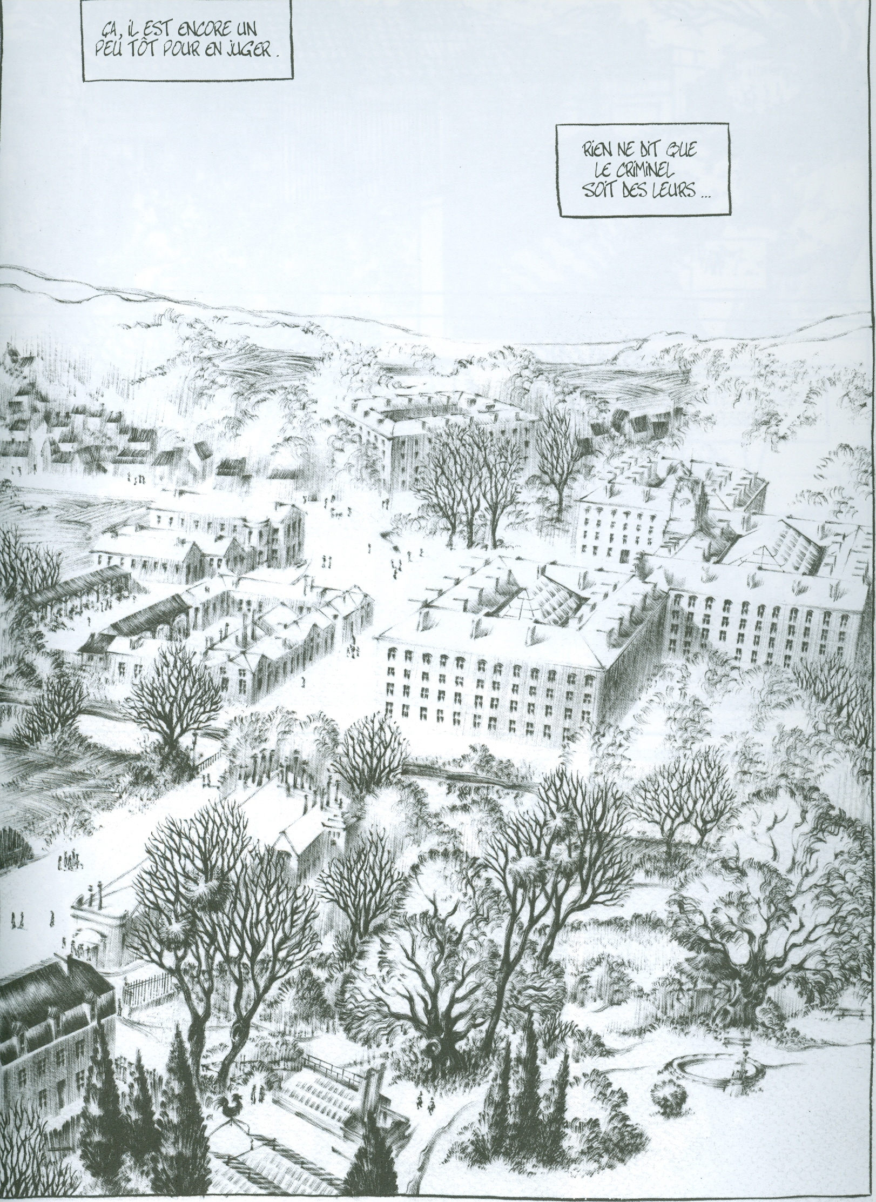
Etapes intérieures
